

**JavaTech Group**



**Payroll Management system for Information Technology Company**

**Use-Case Specification: Export File**

Version 1.0

**Table of Contents**

1. Ordering Book 3

1.1 Brief Description 3

1.2 Actor 3

2. Flow of Events 3

2.1 Basic Flow 3

3. Special Requirements 4

4. Preconditions 4

5. Postconditions 4

6. Extension Points 4

**Use-Case Specification: Export File**

# Ordering Computer

## Brief Description

This use case defines the step of export file. Admin can easily export file from the system by clicking the export button.

## Actor

Admin.

# Flow of Events

## Basic Flow

Admin clicks button export. The system show the option of file extention to the admin. The admin then choose the file name extension they want and click button export. The system return to the admin’s computer a file chosen by the admin.

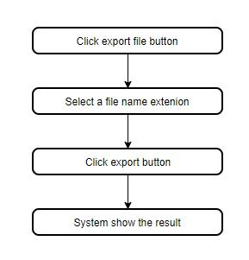

***Basic flow of export a file at a time***

# Special Requirements

No special requirements.

# Preconditions

Free memory is required.

# Postconditions

The admin checks the file after export to ensure the export process is complete.

# Extension Points

No Extension point.